Design, implementation and production upscaling of
novel, high-performance, cluster-based catalysts for
CO₂ hydrogenation

Deliverable D.xx
First report on xxxxxxxxxxxxxxxxx

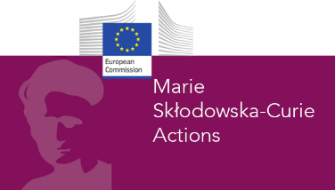

Grant Agreement No: 955650
Project start date: 01.11.2020
Duration of the project: 48 months
Deliverable number 1.1
Deliverable leader DTU
Due date: 30/11/2021 (M12)
Actual submission date: XX/XX/2021
Dissemination level: CO
Author(s): xxxxx

Contents
No table of contents entries found.

Deliverable D.1.1 First report on successful deposition of metallic clusters for ECs

Goal.
The goal is to provide the first demonstration of the successful deposition of mono and bi-metallic clusters on flat substrates and TEM grids

Approach.
We have used the dual laser dual target ablation source to deposit AgAu bimetallic clusters of 2 nm diameter and the new sputtering source to deposit pure mass-selected Ag clusters of different size (Ag7, Ag20 and Ag100) on flat Si wafer surface and on TEM grids. AFM images of clusters on Si wafer and HAAFD-STEM images of clusters on TEM grids are provided as clear evidence of the deposition..

Results.
[xx]

Experimental details.
[xx]

Conclusions.
[xx]

